Proceedings Series 2012/nnn | Compte rendu 2012/nnn

Proceedings of a Maritimes Science Peer Review of the Framework and Assessment for 4VWX Silver Hake.

Part 1: 30-31 May 2012
Part 2 :
Part 3 :

Tana Worcester
Meeting Chair

Bedford Institute of Oceanography
1 Challenger Drive, P.O. Box 1006
Dartmouth, Nova Scotia
B2Y 4A2

DRAFT – May 2012

Foreword

The purpose of these Proceedings is to document the activities and key discussions of the meeting. The Proceedings include research recommendations, uncertainties, and the rationale for decisions made by the meeting. Proceedings also document when data, analyses or interpretations were reviewed and rejected on scientific grounds, including the reason(s) for rejection. As such, interpretations and opinions presented in this report individually may be factually incorrect or misleading, but are included to record as faithfully as possible what was considered at the meeting. No statements are to be taken as reflecting the conclusions of the meeting unless they are clearly identified as such. Moreover, further review may result in a change of conclusions where additional information was identified as relevant to the topics being considered, but not available in the timeframe of the meeting. In the rare case when there are formal dissenting views, these are also archived as Annexes to the Proceedings.

Avant-propos

Le présent compte rendu a pour but de documenter les principales activités et discussions qui ont eu lieu au cours de la réunion. Il contient des recommandations sur les recherches à effectuer, traite des incertitudes et expose les motifs ayant mené à la prise de décisions pendant la réunion. En outre, il fait état de données, d’analyses ou d’interprétations passées en revue et rejetées pour des raisons scientifiques, en donnant la raison du rejet. Bien que les interprétations et les opinions contenus dans le présent rapport puissent être inexacts ou propres à induire en erreur, ils sont quand même reproduits aussi fidèlement que possible afin de refléter les échanges tenus au cours de la réunion. Ainsi, aucune partie de ce rapport ne doit être considéré en tant que reflet des conclusions de la réunion, à moins d’indication précise en ce sens. De plus, un examen ultérieur de la question pourrait entraîner des changements aux conclusions, notamment si l’information supplémentaire pertinente, non disponible au moment de la réunion, est fournie par la suite. Finalement, dans les rares cas où des opinions divergentes sont exprimées officiellement, celles-ci sont également consignées dans les annexes du compte rendu.

© Her Majesty the Queen in Right of Canada, 2012
© Sa Majesté la Reine du Chef du Canada, 2012

ISSN 1701-1272 (Printed / Imprimé)

Published and available free from:
Une publication gratuite de :

Fisheries and Oceans Canada / Pêches et Océans Canada
Canadian Science Advisory Secretariat / Secrétariat canadien de consultation scientifique
200, rue Kent Street
Ottawa, Ontario
K1A 0E6

http://www.dfo-mpo.gc.ca/csas/

CSAS@DFO-MPO.GC.CA



Printed on recycled paper.
Imprimé sur papier recyclé.

Correct citation for this publication:
On doit citer cette publication comme suit :

DFO. 2012. Proceedings of a Maritimes Science Peer Review of the Framework and Assessment for 4VWX Silver Hake. DFO Can. Sci. Advis. Sec. Proceed. Ser. 2012/nnn.

TABLE OF CONTENTS / TABLE DES MATIÈRES

SUMMARY / SOMMAIRE

PART 1: DATA INPUTS (30-31 May 2010)

Introduction 1

Management Unit / Stock Structure 1

The Fishery 3

Current Aging Method 5

Commercial Catch at Age 6

Proposed Aging Approach 8

RV Survey 10

Industry Survey 11

Other Indices 12

Commercial Catch Rates 12

Biological Information 13

Fishery Footprint 14

Bycatch 14

US Information for Context 15

Model Considerations 16

Management Considerations 16

Fishery Footprint (Part 2) 17

Summary of Recommendations and Next Steps 18

REFERENCES 20

APPENDICES
Appendix 1. Terms of Reference 21
Appendix 2. Lists of Participants 23
Appendix 3. Agendas 24

SUMMARY

SOMMAIRE

PART 1: DATA INPUTS

Introduction

The chair of the meeting, T. Worcester, Coordinator for the Centre for Science Advice in the Maritimes Region, welcomed everyone and thanked them for coming to this DFO Science Peer Review of the Framework and Assessment for 4VWX Silver Hake.

Since 1993, silver hake has been assessed 5 times (1998, 1999, 2003, 2005, and 2009). In 1998, there was concern about the large retrospective pattern observed in the population model (a Virtual Population Analysis, VPA, model), and the VPA model was rejected in 1999. No model has been used to provide advice on the fishery since that time. The subsequent assessments have been based on fishery, survey, and other indices. At the 2009 assessment, it was suggested that a review of the assessment framework was in order. A request to initiate a framework review for silver hake was submitted to the Centre for Science Advice in 2011.

As described in the Terms of Reference (Appendix 1), the review of the framework was expected to take several meetings to complete. This first meeting was to review the data sources available for use in the development of the assessment, as well as the methods used to collect and analyze that data.

The DFO Science peer-review process is meant to be an open, transparent, and inclusive process, so participants (Appendix 2) were encouraged to ask questions of clarifications and to participate actively in the discussion. It was explained that the meetings would operate by consensus, where possible.

The Agenda (Appendix 3) was reviewed, and nothing further was added.

Management Unit / Stock Structure

The management unit for silver hake being reviewed in this assessment framework includes NAFO Areas 4VWX. In recent assessments, survey trends in terms of abundance and biomass have been calculated for the Scotian Shelf portion of 4VWX only, excluding the Bay of Fundy (strata 484 through 495), as silver hake found in the Bay of Fundy area are thought to represent a portion of the Gulf of Maine/Northern Georges Bank silver hake stock rather than the Scotian Shelf stock.

Efforts to resolve questions of stock structure of silver hake in this area have provided contradictory results. There have been investigations of blood proteins in silver hake by US scientists (reference). There has also been genetic analysis of DNA at 7 alleles [reference, William Pole?] that indicated Bay of Fundy plus the Gulf of Maine (GoM) was one stock. No recent work on silver hake stock structure has been done in Canada.

The 4VWX management unit for silver hake was originally established based on the perception of discontinuities in distribution. However, in 1999, attempts to resolve the retrospective problem in the Virtual Population Analysis (VPA) by looking at the ECMSAT (Canada/US combined research survey database) did not indicate a discontinuity between the Scotian Shelf and the Bay of Fundy.

Survey trends between the two areas have also been investigated in the past. When abundance was high in the Gulf of Maine, it tended to be high in the Bay of Fundy, but there was no correspondence with the Scotian Shelf. Also, in the past, removal of Bay of Fundy strata tended to improve tracking of age classes.

Discussion

Evidence for two separate stocks on the Scotian Shelf was discussed. Some time ago, Don Waldron looked at meristics/morphometrics of silver hake on the Scotian Shelf for his thesis. He found significant differences between the inshore and offshore. This made him wonder whether there might be a secondary stock. Given the migratory nature of silver hake, however, this wasn’t expected. While he wrote a paper on his findings, it doesn’t appear to have been used by NAFO to change the management area. These results may not have been accepted by NAFO.

A question was asked about the genetics work that had been done on silver hake, specifically whether it had been published. It may only have been published as a NMFS report, but efforts to contact William Pole to find out had not been successful. It was noted that this genetics work may not help with regional stock definition.

There was some discussion about the relative biomass between the Scotian Shelf, Bay of Fundy, and the Gulf of Maine/northern Georges Bank. The US biomass appears to be much larger than the Canadian biomass, and the Scotian Shelf biomass appears to be larger than the Bay of Fundy (about double). The US fishery is about 10,000 t [check]. Historically, it was a lot larger. The US fishery shows a similar trend to the Canadian fishery.

In the RV Survey Trends document (e.g., DFO 2012), different strata are used to plot trends for silver hake (Eastern Scotian Shelf, Western Scotian Shelf, and the Bay of Fundy). This report shows different trends in the Western Scotian Shelf and the Bay of Fundy. Comparison of these types of trends might be useful.

Comparison of the trends in the abundance between the Scotian Shelf and the Bay of Fundy were investigated prior to 1999, but these trends have not been looked at more recently.

Trends in weight at age might show differences in growth, which is not a stock structure issue but may provide a reason for managing these areas differently.

It was noted that there had been some joint Canada/USSR research conducted after 1978 (maybe in the early 1980s by Don Waldron’s group). This work hadn’t been reviewed for this data inputs meeting, as it was conducted a long time ago and may no longer be relevant. There was an ickthyoplankton component of the research (didn’t help with stock structure), with some groundfish work to address more fishery-type questions.

It was asked whether climate change might have an impact on the distribution of the silver hake stock. It was suggested that it might, but this hadn’t been investigated to date and it would be a hard question to answer.

It was noted that information from the Scotian Shelf Ichthyoplankton Program (SSIP) is included in the working paper, but the Fisheries Ecology Program (FEP) data is not yet included in the review. FEP was only done in 4X, but it covers the area where discontinuities in the stock have been proposed. In addition to ichthyoplankton work, the FEP program also conducted seasonal groundfish surveys which may be helpful in looking for discontinuities in distribution. Mark Fowler may have looked at this.

The Bay of Fundy larval herring survey reported some silver hake larvae (according to Gary Melvin), which may be useful to consider.

It was asked whether it would be possible to explore different management configurations during the model review. However, it was explained that it would be difficult to separate the catch at age. Agreement would need to be reached on the assessment/management area to ensure that the relevant data could be provided for the model review.

There was some discussion on whether silver hake stay within the 4X basins, or whether it was possible that there is migration from the south up into the 4X basins. The Scotian Shelf edge is sampled so poorly, and the signal is too noisy to look at it. Length frequencies had been compared for offshore and inshore areas, and there is some evidence for differences in the length-frequencies between these areas; however, this might just be a seasonal difference. The conclusion of past investigation was that the basins might be a nursery area where young fish congregate. The March survey does cover Emerald Basin, and it only see small fish. In the summer, a broader age range is observed. This would be more interesting in terms of stock structure if there were larger fish in the basin all year.

Figure 20 shows ripe and running silver hake, and it doesn’t appear to indicate a discontinuity in the distribution. However, this may be an artifact of having so many years plotted together. Silver hake are serial spawners (2-3 times a year). They can have protracted spawning, but it occurs mostly in the summer.

Recommendations

Past genetics work, blood work, and rationale for 4VWX management unit should be documented in the final Research Document.

Steve Campana to check historical research papers (Canadian/US joint research) to determine if there is any relevant information related to stock structure.

Mark Fowler to be asked if he looked at the FEP groundfish results for silver hake. If not, look at the FEP survey on the Virtual Data Centre (VDC) [Note: part of it is there: January to June, 1982-1985].

Include FEP ichthyoplankton and Bay of Fundy larval survey results along with the SSIP information for silver hake in the final Research Document.

Additional analysis was to be presented to assist with determination of a stock area for assessment purposes: trends in total or mean catch per tow (strata 440-483, 484-495) and age specific biomass from the RV survey for Bay of Fundy and Scotian Shelf combined and separately; mean catch per tow for the ITQ survey combined and separately; catch distribution plots from the RV and ITQ surveys for the full area to help look for discontinuities. Some of this work was presented later in the meeting.

The Fishery
Working Paper: Silver Hake Framework Assessment. CSA Working Paper 2012/042.
M. Showell

There have been no foreign catches since 1999, when they were excluded from Canadian waters. All catches have been Canadian and at a lower level since then.

Proportion of catch from Basin and Slope (Figure 3) and the distribution of the fishery (Figure 4) were presented. The fishery occurs mostly in the basins, with Emerald more popular than LaHave. There is some bycatch of silver hake in the redfish fishery. In 2010, see some catches along the Georges Bank (GB) line (catch or bycatch?), but only about 50 tons. Note the 2011 catch from the small mesh gear line.

Important changes in the fishery include: the change in mesh size and shape from 60 mm diamond to 55 mm square mesh when the fishery became “Canadianized”. This affected all Canadian licenses right from the beginning. Also, the foreign fishery was conducted from April-Aug, but the Canadian fishery is year round (dependent on market).

Discussion

A question was asked about the reported catch for 1973, and whether it was likely to be an overestimate. It doesn’t seem biologically possible, and it may have been due to intentional or unintentional misreporting. Similar misreporting has been documented in other fisheries. One explanation is it might have been prorated from a test fishery (i.e., estimation) rather than actual reporting. Earlier assessments only used catch data starting in 1977.

It was noted that foreign catches appear to have reported in 2003. In 2003, there was a joint venture, and catches might have been reported from that (Russian vessel).

There appears to be a copy/paste error for USSR and total catch for 2009 and 2011.

It was noted that the catch in 2010 appeared too low and may be in error. Egypt was a big market, and when their currency devalued, they stopped buying Canadian silver hake. Market is now Europe, with some going to the US and Toronto. However, even with that, 2010 looks too low. It should be at least 9,000 t. This was later determined to be an error.

It was noted that the catches in Table 1 and Table 2 were not consistent and should be checked.

It was asked whether the distribution of total catches could be plotted (not just the observed catch). There was some discussion about whether plotting of total catches would show any difference in distribution from the observed catches, and whether the observed catch could be considered representative of the fishery. It was suggested that this would be good information to have demonstrated. The coordinates of each set is recorded in the logbooks, and VMS is required. It should be possible to compare distribution from the observed trips to distribution of the fishery from logs or VMS.

If the port sampling and observer sampling is similar, than the observed catches could be considered to be representative of the fishery. However, demonstration of this would be useful.

It was also suggested that the catch along the GB line should be checked to determine the source of this catch. The silver hake fishery is not allowed to fish that far west, so it might be bycatch in another fishery or an error. It was considered to be unlikely to be a coding error.

It was asked whether all three sources of information (observer data, port samples, and industry samples) go into the catch at age. It was clarified that they do, but there are no otoliths taken from the industry sampling. It was suggested that if there were a few years where there were samples from all three data sets, these could be compared. It was noted that observer samples come primarily from the 1st and 4th quarter.

A license for squid was issued in 2011, which may have caught silver hake. It didn’t catch much squid.

Catch indicated just outside of Halifax is probably a key punch error.

In the last assessment, was the foreign fishery catch at age used? Yes. Would expect mixing in the location of the foreign fleet, and they used different gear from the Canadian fishery.

Another important change in the fishery that would affect catch composition is that a separator grate was introduced in 1993. There may also be an effect of strengthening straps (and zipper) on gear selectivity.

Was there a period where both meshes were used? Transition to square mesh was essentially overnight. There was limited overlap in the distribution of Canadian and foreign fisheries.

Recommendations

Define “basins” and “slope” in Figure 3 or use other terminology.

Check errors in foreign (and total) catch in Table 1. Compare catches in Table 1 and 2 to ensure consistency. Specifically, check 2010 landings as they are not correct. (Do this through MARFIS directly, as the VDC is giving wrong numbers).

Check the catch to the north of Georges Bank.

Plot distribution of the fishery from logbook positions or VMS (years?).

Compare catch composition from observers, port samplers and industry samples for a few years/quarters where there are all three.

Recommend catch at age starting at 1993. Silver hake is a short-lived species, so this might be a sufficient time series. It is worth a try. Pros: wouldn’t need to worry about vessel calibration. Explore both – base case and truncated one. Put the emphasis on the recent period. If there is mixing along the shelf edge, would get different reference points. However, there is fishing occurring on the edge.

Current Aging Method
G. Young / S. Campana

Clear otoliths in glycerin, but the problem is that they continue to clear and some structure is lost. It would be nice to have a permanent collection. Currently just reading the last 4 years. Efforts are being made to try to prevent the age “drifting” seen in other stocks. In the US, they use a crack and burn approach. Now imbedding in a microtome (individual sections), which is labour intensive, but their otoliths are readable for a longer time.

Currently missing some of the aging, which will be completed by July. The full catch at age will be ready by September.

*** Note: for aging subsampling, used strata 440 – 498. Could discard the deeper sets if need be.

Discussion

Can you test the settling check to determine if they might be ready before July? There will continue to be some confusion between Age 0 and Age 1. When would you see the Age 2s? Probably now. Problem occurs in larger fish.

Did you try imaging? Yes, but it didn’t work out. Because of the curve and number of surfaces you can look it, can’t get the whole thing in the one screen shot. Tried some other tests, but they haven’t worked either.

Is there an imaging solution? It might be worth trying again. If Jerry Young drops a box off with Steve Campana (Josh), they might have better luck. They have a new set-up for imaging.

Sectioning changes? Did the match guard comparison, but not a good comparison. Sectioning shows fine scale structure that’s hard to interpret. Not trained to read these sections.

There is someone in the State of Maine who is working on silver hake aging. Exploring methods. Peter Comeau will find a contact. More useful to get section from the Woods Hole lab. Could try to bring them back from TRAC in June.

Recommend an exchange with Woods Hole. Could check ages and compare methods at the same time. Might want to do an independent check with someone in PED who doesn’t do silver hake. Only expect this to be an issue for older fish.

Commercial Catch at Age
Working Paper: Silver Hake Framework Assessment. CSA Working Paper 2012/042.
M. Showell

Figure 5. Age 1 and 2s have increased since 1999. Bigger component of the catch now. This is coincident with the Canadian fishery.

Figure 6. The proportion of Age 1 and 2 in the total catch. Risky or dangerous strategy. They mature early, but catch a lot of them before they spawn. Age of maturity is 100% of males at 2 and 75% of females at age 2.

Figure 7. Weighted average. Commercial mean weight-at-age. Not a biological index anymore. Might use it for projections. Check final year. Compare with Table 4 (don’t look at 2011 row).

Discussion

It was clarified that males and females have separate age length keys, and then they are combined.

Numbers are falling off in the Figure 5, but landings don’t do that. Taken from Table 3. May be related to the age of fish being caught in terms of biomass.

Catch at age by sex, age, and season? Broken out by foreign and domestic, quarter, and sex. What is the rationale for breaking it out by quarter? Don’t recall. Have enough otoliths to do this. Any evidence of change from quarter to quarter? Haven’t looked. Gerry didn’t notice any difference. The 2011, did find a higher proportion of 0 fish. Could have changes in the fishery based on market. Can target smaller versus larger fish in certain times of the year.

Are we sampling / aging enough? Some of the numbers seem low for an age-length key. 200 would be typical. When you divide by sex, it gets low. Can get a CV from the catch at age – could optimize this. Peter Comeau looked at the CVs. CVs are great for Ages 1-3 but then get bad after that for some groups. Have to make up ages for upper ages (15-20 fish), but usually don’t represent much of the catch. Industry collects a lot of length-frequencies without otoliths. If someone runs into big fish, may not get otoliths from the samples. Hard to fill in. Can easily increase the number fish aged in each quarter, but is it constructive? Already aging all the older fish (fringe). When selecting otoliths for aging, don’t go by sample. Combine all otoliths into one pot, and then break it out – 5 per cm per sex. Looked at what proportion weren’t aged – mostly where the bulk of the distribution is.

Does that suggest more sampling? Yes, as opposed to more aging of existing samples. Have asked port samplers to increase above one per month (Port Mouton).

Boats land at 7am at Jedore. Packed there. Enough time to get there? Yes. Can talk about this afterwards with Ray Belliveau.

Can’t you fill these in from the RV survey? Same sampling problem with the RV survey – see them but don’t always sample them. Do see them in the fishery, so they could be sampled from the fishery. Tend not to use RV ages for the commercial fishery.

We’ve had some vessels along the small mesh gear line. Have you looked at the difference between fish caught (ages) with and without the grate? 5% of fish lost when using the grate (don’t know if it was Canadian or foreign fleet). This 5% is the larger fish. Different size structure of the catch with a grate. Might be other fleet changes that have impacted this also. Documentation of this would be useful (proportion of sets for various year classes). Tonnage class made a lot of difference for pollock (fish being able to escape the trawls). Foreign was “offbottom” – within 6 feet. Definitely different gear and fishing practices.

Don’t totally buy the idea that you can’t catch the older fish, since we did see them in the RV survey at some point. Unlikely that silver hake could outswim the gear at 3 knots.

In general, markets may want the smaller fish sometimes. Changes weekly. Report daily on the size of the fish.

Catch at age tracks well from 1999 on for younger fish, then seems to fall off. Might be that ages at older fish are wrong. Need an independent check on the ages. Exchange with Woods Hole. Could compare methods at the same time. Might want to do an independent check with someone in PED who doesn’t do silver hake. Only expect to be an issue for older fish.

Recommendations

Describe the methodology used to subsample. Also describe the rationale for separating into domestic/foreign, sex, and quarter.

Document proportion of sets by various gear classes.

Would like to see a bubble plot for commercial catch at age and RV survey (on same page).

Want to see commercial length at age as well. To disentangle condition, would also need to see length at age. Label the ages on Figure 7.

Explore using full catch at age and catch at age starting in 1993: i.e., base case and a truncated one, though might want to put the emphasis on the recent period.

Need some additional discussion of sampling. Doubling might not be the right strategy. Might focus on larger fish (above 35 fish) or smaller fish that you come across.

Proposed Aging Approach
Working Paper: Age determination without tears: statistical estimation of silver hake age composition on the basis of otolith weight and fish length. CSA Working Paper 2012/041.
S.Campana

A few years ago, did a survey of aging labs around the world. Millions of otoliths that are aged every year. Big business. A major client is stock assessment. Don’t require the age of the individual fish, need the catch at age. When you look at it that way, there are some new approaches that can be used that are based on very strong biological principles. Fish of the same size will have different otolith size based on growth – one that reached a size more quickly should have a smaller otolith. Do get more information if you know the size of the fish, the size of the otolith, and the weight of the otolith.

Figure 1. Cod of known age. Born in a hatchery, tagged, released into the wild and then recaptured. This shows a clear relationship.

Figure 2. Clump out for age 2, age 3, with a bit more overlap between ages 4 and 5. Can tell the difference statistically.

Need a sample fish that you’ve aged and measured, to compare to one that you haven’t aged. Need to have consistent growth. Use a statistical model. Ages 7 and 8 seem to have a different growth rate. Restricted analysis just to females. Overall, years are similar in terms of growth rate and size. A few differences at older ages.

Figure 5. Males are smaller.

Assumptions: whatever you’re using to train the model is broadly representative of the whole sample. Problem is that we don’t have true ages. This produces imprecision – this uncertainty exists already within the catch at age. Can’t get results from models that are better than this.

Looking at several different models, Omix-S came the closest to the current aging values. In the order of the aging uncertainty. This is a best case scenario since it was a subsample.

Using a more realistic case, Omix-R came closest. Did a pretty good job except for age 5. Follows the pattern reasonably closely.

Currently have a single ager for silver hake. Could use existing samples to age the 2012 otoliths.

What happens if you have samples that are too far from your reference group? Example – looked at 1990. Didn’t do so well for age 7s (small sample size). Didn’t do as well overall. This would be a problem with the approach – don’t want to use the same reference collection for too many years in a row. Could use it to predict the next year. Don’t know how many years to use it in the row. Don’t know if you could use it to predict commercial catch at age. Different size selectivity in the RV.

Other species? In silver hake, age composition dominated by younger fish, which this method works well for. Might work well for herring and salmon.

Problems with re-weighing. Next year, could weigh them before the glycerin.

Discussion

Looks promising. There is no difference in the two otoiths (right and left)? Not identical weights, but no bias.

How would it deal with large year-classes when there might be a compensatory mechanism (like haddock)? It would be very easy to distinguish that year class using this method – since they are growing more slowly.

Have you calculated von B from this? Could do that. Advantage of this approach is that you can avoid doing that. There is a program (otofan?) that generates the catch at age directly from this.

Sample size? 700. Group being predicted is in the order of 200. Is it better to age a small number every year or a larger number every three year? Probably a small number every year to check growth rates – but growth does seem stable.

Do you usually weigh otoliths? We don’t but other groups do throughout the world. Some labs doing it routinely.

Change in condition in 1993/94 – seen in other fish. Length at age has been more stable than condition. There has been a decline in length at age early on, but stable since about 1999.

Reference group – would support need to check for aging error. You can build aging errors into the model. We don’t do that here, but it can be done.

Could try this on haddock. More savings if you use it for other stocks.

Recommendations

Attempt to generate the indices for a few years to review at the assessment.

Working paper accepted for conversion to a Research Document.

RV Survey
Working Paper: Silver Hake Framework Assessment. CSA Working Paper 2012/042.
M. Showell

A stratified random design groundfish research vessel (RV) survey has been conducted on the Scotian Shelf from 1970 using three Canadian research vessels (A.T. Cameron, Lady Hammond and the CCGS Alfred Needler). Excluding Bay of Fundy and approaches for the indices. Not stratified for silver hake, but stratification isn’t worse than no stratification.

Based on an analysis of comparative fishing experiments by Fanning (1985) a conversion factor of 2.3 is applied to the abundance series prior to 1982 to account for the effect of vessel and gear changes between the A.T. Cameron (lower trawl) and the other two vessels. The same conversion factor was used to adjust biomass estimates. Based on a limited number of observations. Still a retrospective whether you use the conversion or not. No conversion factor is required between the Lady Hammond and the CCGS Alfred Needler for this period. The survey was conducted by the CCGS Teleost in 2004 and 2007. An analysis of comparative fishing experiments showed no conversion factor was required between the two vessels for silver hake. May not be an issue if we cut off the indices to some more recent time period.

Distribution at RV Survey Catches: Don’t see break in distribution when you look at the recent distribution of RV survey catches (2008-2011). May be cause to reconsider excluding the Bay of Fundy in the indices.

Total Biomass : 1970 to 2011.
Total Abundance : 1970 to 2011.
Recruitment : 1970 to 2011. Would normally shift over by one year and call it year-class. See 2009 year class as the largest in the recent time series.
2+ biomass : seeing increase.

Criticisms in the Past: With a decrease in condition, are more going through the RV mesh? With change in species composition, is there a change in catchability? Are they moving deeper? Looked at deeper strata and didn’t see anything.

Discussion

In the conversion analysis, did it look at difference in size? Yes, did look at sizes. Can get reference from NAFO website. NAFO SCR 85/64.

Looks like the 2009 year-class was the lowest in a while in the commercial catch at age – despite being highest in the RV survey.

Length data for the RV survey? Not yet. It’s around. Check how it’s done in the RV Survey Trends (e.g., DFO 2012).

Since silver hake are sexed, is it possible to generate a spawning stock biomass (females)? 75% mature at age 2. Do you generate an SSB index? Just assume that all females are mature at Age 2.

Did you look at survey Z this time? Looked at difference combinations, and nothing obvious on how to do it. What would people suggest? Figure 20A in 2010 Res Doc that looks informative. Figure 9 in the SAR. Provide for tomorrow.

Recommendations

Add table for 2+ biomass.

Female-only spawning stock biomass plot (Age 2+ or something fancier).

Plot total Z for Ages 1-4 as in the SAR from 2010.

Summarize length frequencies from the survey (see RV Survey Trends report).

Update proportion females (sex ratio).

Update maturity ogive (percent mature females at age) to determine whether age at maturity of females has changed over time.

Industry Survey
Working Paper: Silver Hake Framework Assessment. CSA Working Paper 2012/042.
M. Showell

The ITQ survey doesn’t cover whole stock area. However, it does cover the inshore area better. Don’t find a lot of silver hake there. Haven’t plotted catches yet.

Figure 14 is abundance and biomass for all ITQ strata.

Discussion

Are stations sampled every year? Yes. Covers the whole area of discontinuity between Scotian Shelf and Bay of Fundy.

Get smaller fish in both the ITQ and the RV survey in the slightly deeper water.

Some stations have been added on. Big addition was in 1996. 1995 not included in the series. Same core of stations? Some differences from year to year. When Don did this for cod, needed to use a core set of stations (ones that have been sampled every year). Have dropped stations due to gear conflicts – have excluded these. Haven’t dropped ones if not done for a single year. This is a simple mean anyway.

Recommendations

Plot the distribution as supporting evidence for the management unit.

Plot trends in total strata and SS/BoF split.

Other Indices

0 group survey conducted by the Russians in October from 1980-1997 -- just on the Scotian Shelf. Used this as a tuning index in the VPA for a number of years. Tried for 2 years using the Needler, but it didn’t work.

Lots of silver hake in the diet database. Could look at this for an abundance indices.

4VsW Spring Survey – not informative.

Is it useful to compare to US Surveys – stock-recruitment relationship? US fall or spring – maybe just in the GB survey.

GB Survey trend for tomorrow. Shows mostly on southern flank in warmer water.

Commercial Catch Rates

Figure 15. Catch rate from the foreign fleet. Candidate for an index – rationale: conducted in a limited geographic area, same vessels, same gear, same methods, primitive methods for finding fish. Used as a tuning index in the VPA in the past. Standarized by NAFO area, country and month. In 1999, Russians kicked out of the Canadian zone.

Figure 16. CPUE for 4W in July 1996-2008. Not just vessel but the skipper… Don’t know if I should bother to try.

Figure 17. Relative F was also plotted as the ratio of commercial catch over the stratified total biomass estimate from the RV survey.

Discussion

Record of skipper in the log? No.

For the last 6 years, no turn-over in skippers for 70% of landings. They stick with a vessel. Is it worth developing a trend since 2006? Would need to go back to 2000.

Some changes in the fishery through the year. Dec - May can catch what we want. After that, can’t control fishing. Leave the boxes. Limited to certain areas.

May also be a diurnal effect – different for morning and mid-day. Should be averaged out. Related to winds.

Tons per day or tons per hour? Actual days in the past. Should look at set time – actual hours (duration) in the water.

Would this type of index continue to be useful? Probably.

Recommendation

Develop a mixed effects model using a core group of vessels that have kept the same skipper since 2000 (Fundy Leader came in 2006), with CFE as a main effect. Vessel has to be in the fishery for X number of years. If one vessel had a different trend, could exclude it. Divide into two seasons: Dec – Feb and then March - May. Also base on actual hours (duration) in the water instead of days.

If you use as a tuning index – could look at mean square residual to see if it improves the model fit.

Biological Information

Condition and mean length-at-age has declined. This means low mean weights-at-age. Plotting weight at 25 cm (calculated for males and females and then combined).

Proportion of females over time from the RV survey (females disappearing) is changing. It would be important to update this. What would be the impacts on fecundity?

Figure 23. Spatial distribution from the RV survey from the VDC. 60% were non-zero and 40% were zero.

Discussion

Any recent literature on biological characteristics? Last assessment in the US done in 2011 and 2006. Did come up with a new assessment analytical model. No new information.

Should keep males and females separate for condition. Do it at age 3 for females (100% mature). Can keep 25 cm for males.

Typically see a different metric for area of occupancy, such as DWAL. Also, should look at any changes in area of occupancy for spawning biomass (in addition to total or juvenile biomass).

How hard is it to incorporate Area Occupied into the VDC? Easy, as it is already done. Stratum weighted area occupied is the most recent, which was requested by Don Clark.

Recommendations

Check last US assessment for any new information (2006 or 2011?)

Separate males and females in condition index. Use size at age 3 for female index. Use size (25 cm) at age 2 for males.

Document reduction in proportion of females in the RV survey.

DWAL for spawning stock biomass and then immature from VDC.

Fishery Footprint
J. Black

Figure 1 is a demonstration of spatial analysis work done in 2008 to identify Ecologically and Biologically Significant Areas for the Maritimes Region. It uses a method that partitions landings in the bottom third, middle third, and top third, to show where most of the landings are occurring, as well as partitioning effort into days fished. It demonstrates that most effort is less than 2 weeks. It was noted that there might be some bad data (wrong coordinates) from MARFIS. The distribution of fishing effort in 2007-2011 appears to be fairly similar to that in 2011 alone (Figure 2).

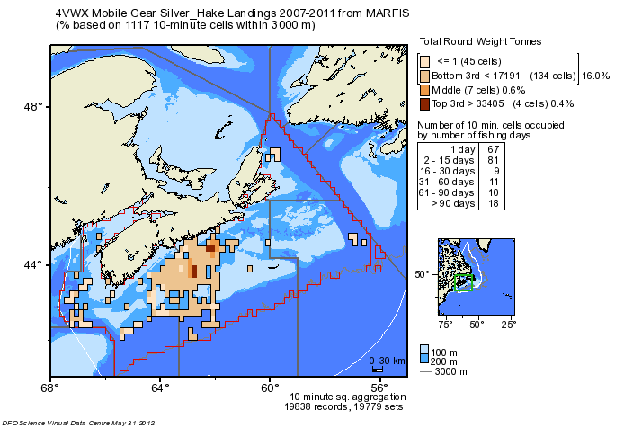
Figure 1. Distribution of silver hake landings from MARFIS in 2007-2011.

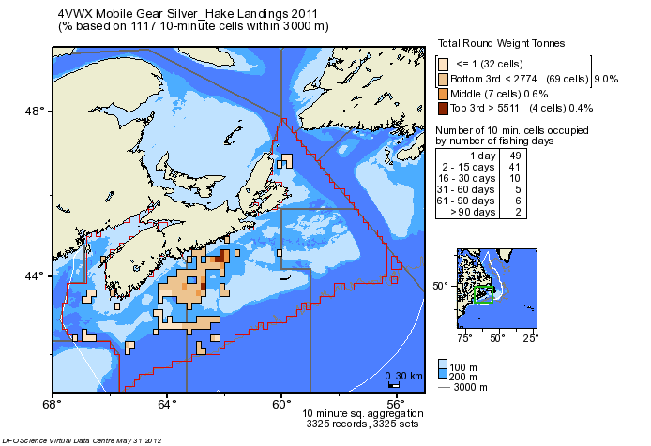

Figure 2. Distribution of silver hake landings in 2011.

Discussion

Is the >90 days indicated per year or cumulative? Cumulative over the time period.

Estimated weight or prorated weight based on landings? Probably the prorated weight.

All mobile gear and not just silver hake fishery? May not have been sorted by mesh size.

It was suggested that there is lots of other work that needs to be done for this framework, so why would we include this type of analysis. It was suggested that, in addition to supporting work on potential habitat impacts, it does present another way of looking at the fishery distribution information. Bubble plots don’t really give a good indication of the distribution of the fishery.

There is another aspect of spatial assessment models – good to start the discussion.

This type of information may be useful for eco-certification purposes. Is landings data enough? Not for Marine Stewardship Council certification in scallop, but haven’t been asked for it in groundfish. It would be in industry’s best interest to get a more precise estimate of their fishery footprint.

Recommendations

In addition to the plot provided by Jerry Black, include a plot that limits analysis by mesh size (55-90) with that gear to distinguish targeted and non-targeted [see additional information provided below]. Could also divide into the two proposed seasons to get the temporal distribution.

You could also link a subset of landings to the VMS data. Cross against logs as an independent measure of effort. Can look at speeds in the VMS (use derived speed). Based on distribution of speeds, can estimate when fishing occurs. If you trust the landings - could get a separate CPUE from VMS in addition to logs. VMS prorated to landings. Use this to validate log records.

Check Scott-Coffen Smout’s group analysis of the silver hake fishery. 2002-2009 fishery profile for silver hake. Don’t know the scale the analysis was done at. Scale does influence the results. VMS would fine tune it – landings over-estimates it.

Need to fine-tune the question we are trying to address.

Bycatch

Table 8. kept and discarded catch for the last 10 years (2002-2011) from the observer database. Herring is 1%. Others are less than 1%. Catches lots of species but not many.
Discussion

List any SARA listed species : skate, basking shark, cod.

What is offshore hake? What is included in squid (NS)?

What is the percentage? Total catch.

This looks like an adequate level of observer coverage.

Discarded silver hake? Damaged fish. Not permitted to discard. Net tears (estimate).

Lobster has to be thrown back. Says here that it’s kept. Strange that lobster is in the observer records. May be keypunch error? Probably was lobster. Don’t have to sort if it’s just silver hake. Ask Peter about this.

SARA logbooks? Yes, these would be available but may be hard to identify the silver hake trips. Can just sort by mobile gear less than 65.

Define what you mean by adequate observer coverage.

Recommendations

Include all species in the bycatch species table. Include the level of observer coverage as percentage of observed landings.

Check any SARA logbook records if possible to distinguish silver hake trips.
Day Two

Review of Day One
T. Worcester

A summary was provided of Day One. Additional discussion is required to determine the assessment area for consideration in the modeling workshop and subsequent assessment.

Discussion

After some further investigation overnight, there does seem to be an apparent higher mortality rate on older fish. This leads to further concern about the aging of older aged silver hake. It is highly recommended that an independent check of ages be done prior to the analysis of the catch at age.

There was a problem with the catch at age system – system crashed when attempted to enter 0s, so had to replace them with 1s. This is a different issue and not as important.

Need to address the question of whether Bay of Fundy / Gulf of Maine silver hake might be a transboundary stock.

Comparison of Survey Trends

Alain d’Entremont provided a comparison of the US survey trends with Canadian survey trends, based on information acquired from US assessment reports and Canadian data. Areas discussed are displayed in Figure 3
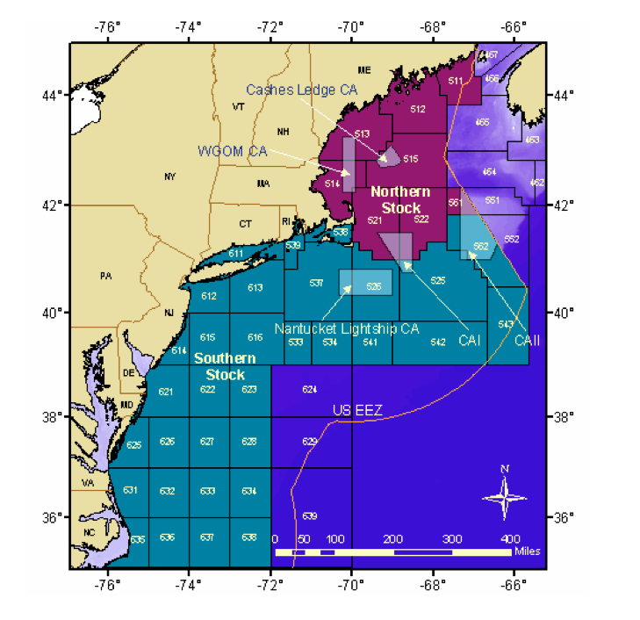
Figure 3. US survey strata and stock areas.[reference]

First he showed the recruitment index and 3+ biomass for Northern and Southern US fall surveys (Figure 4).

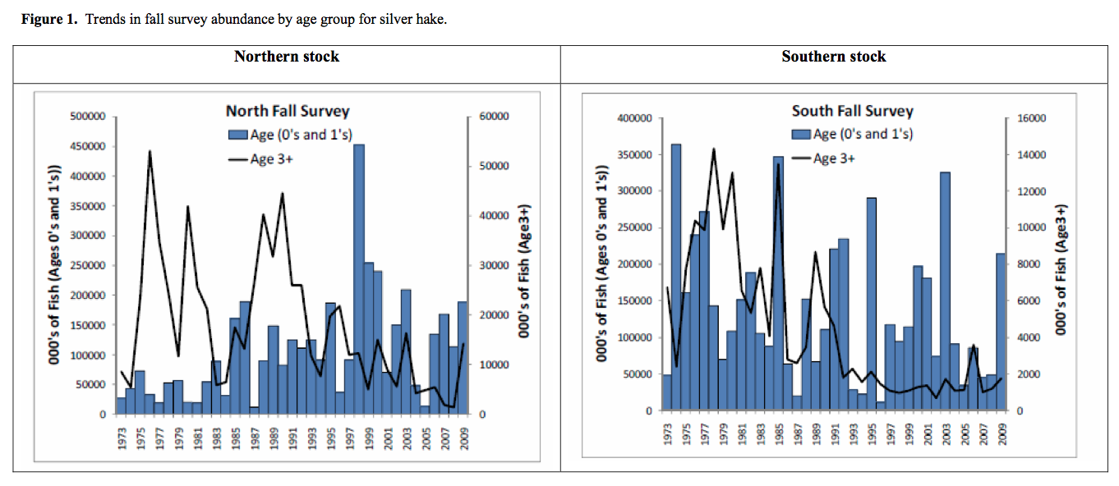

Figure 4. Trends in fall survey abundance by age group for silver hake in the Northern and Southern US stocks [reference].

He also showed a comparison of the Canadian RV survey catch per tow and the trend for the US Southern stock, which seemed somewhat comparable in terms of overall trends, as well as the US Northern Stock, which did not seem as comparable (Figure 5).

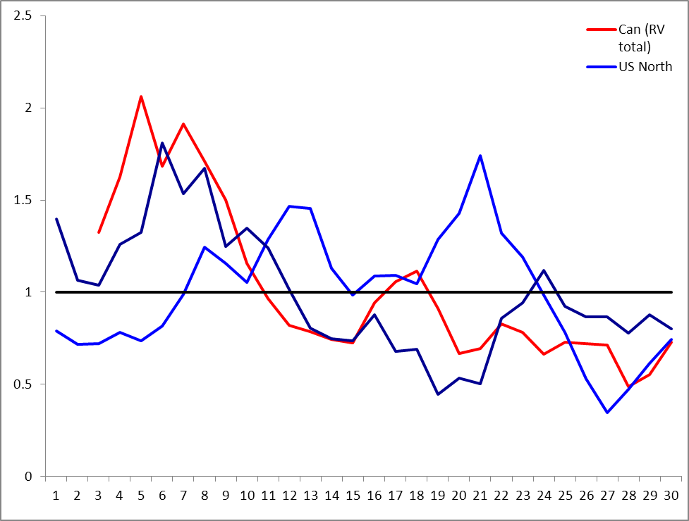

Figure 5. Comparison of the Canadian RV survey trend with the US Northern and Southern stocks.

Looking at the Canadian survey trends alone, there appears to be limited influence of Bay of Fundy on the combined index (Figure 6). This is not surprising given the Bay of Fundy has about half the catch rate of the Scotian Shelf and represents a smaller area.

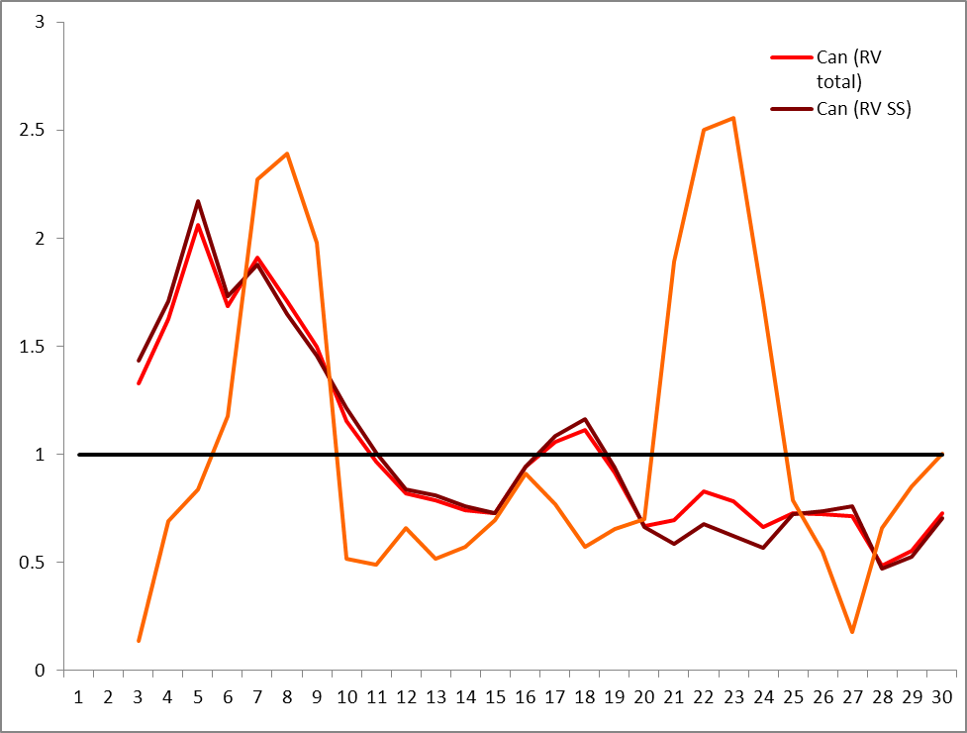

Figure 6. Comparison of the Canadian RV survey trend for the Scotian Shelf (SS), Bay of Fundy (BOF) and combined.

Discussion

There was some discussion on whether efforts should be made to acquire the raw US data to attempt to fit a model. It was agreed that it would be a lot of work to rebuild the catch at age, though it may be possible to just use the two that exist and add them together. However, they don’t cover the same area.

Recommendations

Recommend using a simple correlation table to provide more objective way of comparing the survey trends.

After some further review and discussion, it was agreed that the information available does not support adding the Bay of Fundy to the catch at age and it was agreed that the assessment should continue to be based on the Scotian Shelf component only.

Model Considerations
- Base Case – traditional VPA formulation:
  - Age-based VPA
  - Was used for a few years – people might not have looked at it closely enough
  - Always had a retrospective
  - Tried a number of different tweaks: Truncated data, etc.
  - Hoping for something different
- Possible alternative models for exploration: stage-based model or delay-difference model.
- Need to resolve if there are aging errors.
- Steve Martell will be coming to do a week long workshop on modeling in September: will be looking at statistical catch at age models – from simple surplus production models to more complicated models.
- Selection of a model will depend, in part, on how much confidence we have in the data.
- Will have a week to talk about what works and what doesn’t
- Sharp contraction of age structure in catch in 1993 may cause problems for the model, but it would be possible to set objective function to account for this and make use of different time periods.
- This change in 1993 shouldn’t have an influence on the retrospective now, but it may be a reason to truncate the data. Still had a huge retrospective in 2009.

Management Considerations
- Ability to generate reference points and harvest control rule.
- 5 year assessment cycle (possibly) – projections may be important
- What do we do in the interim? HCR. More empirical approach in the interim.
- Will have an RV survey trends report to monitor.

Fishery Footprint (Part 2)

A new figure from J. Black was reviewed, which just included mesh sizes from 55-89mm (Figure 7). This didn’t appear to change the distribution of the fishery much. It just removes some of the bycatch. Top 10 cells are the same from year to year. There are still records north of Georges Bank.

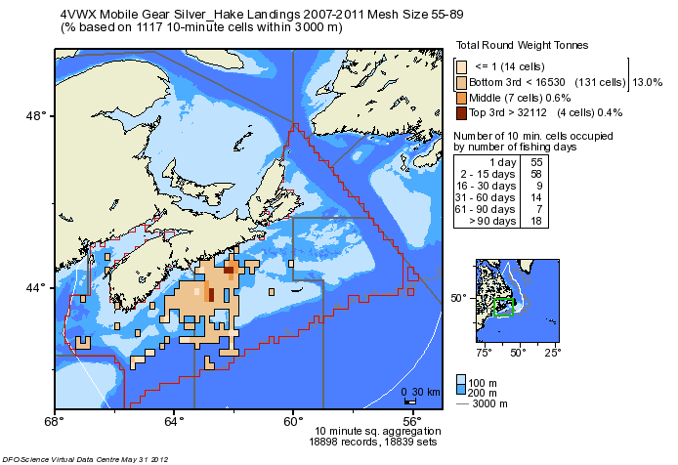
Figure 7. Distribution of silver hake landings using mesh size of 55-89mm (2007-2011).
Another figure was provided for 2011 alone (Figure 8). This indicates a smaller footprint (as expected).

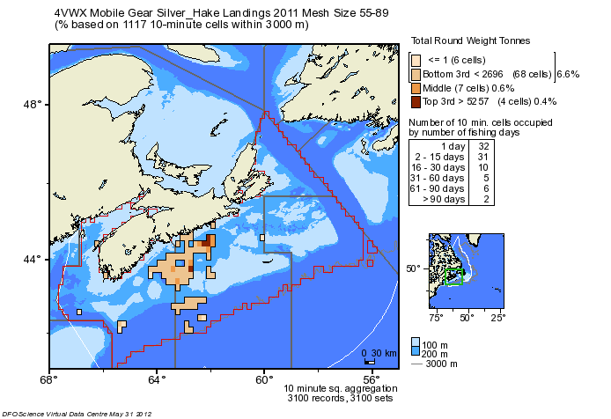

Figure 8. Distribution of silver hake landings using mesh size of 55-89mm (2011).

Discussion

Someone asked how deep the fishery can fish. It was clarified that silver hake fishing typically occurs at 700 fathoms or less.

Need to check with J. Black to ensure the analysis was limited to groundfish mobile gear only (not shrimp gear).

Some concern was expressed that if the Sensitive Benthic Area Policy goes through and there are two additional closed areas for Vezella sponges, that this would impact the silver hake fishery.

SUMMARY OF RECOMMENDATIONS AND NEXT STEPS

Management Unit / Stock Structure

Review of information presented at this data inputs meeting suggests that using Scotian Shelf RV survey information (excluding the Bay of Fundy strata) as an index of abundance will be adequate to reflect the relevant silver hake population.

Next Steps
- Document past work, including:
  - Genetics work
  - US blood work
  - DFO Maritimes rationale
- Document silver hake distribution between Scotian Shelf and Bay of Fundy (as evidence to support management unit):
  - RV survey (longer time series)
  - ITQ distribution
  - FEP groundfish surveys?
- Document survey trends for Bay of Fundy / Scotian Shelf separate and together.
  - mean catch per tow in RV and ITQ surveys
- Document egg/larvae distribution information:
  - FEP ickthyoplankton survey
  - Herring larval survey
  - Historical 0 group survey

Fishery Information

Check :
- Errors in foreign (and total) catch in Table 1.
- Match Tables 1 and 2. e.g., 2010 landings don’t seem to be correct.
- Catch to the north of GB.

Plot :
- Distribution of landings from the logs or VMS.

Analysis
- Compare catch composition from observers, port samplers and industry samples for a few years/quarters where there are all three.

Aging

Short-term
- Currently subsampling using strata 440-498 – discard deeper sets?
- Describe subsampling procedure.
- Complete aging (before July, if possible).
- Attempt to generate catch at age from otolith weights for assessment – Steve
- Provide commercial length at age

Longer-term
- Gerry Young to provide samples to Steve/Josh to reattempt imaging
- Exchange with Woods Hole to do independent check of ages and compare methods (sectioning) (attempt to bring samples to TRAC meeting in June)
- Local independent check on ages also.
- Peter Comeau to find contact of someone exploring aging methods in Maine
- [try method for haddock]

Commercial Catch at Age:

- Describe rationale for separating into foreign/domestic, quarter, and sex. Note differences by quarter.
- Document proportion of sets by various gear classes?
- Label ages on Figure 7.
- Provide commercial length at age (to help disentangle condition).
- Provide bubble plots for commercial catch and RV survey on same page.
- Explore using full catch at age and catch at age starting in 1993: i.e., base case and a truncated one, though might want to put the emphasis on the recent period.
- Additional sampling – focused on larger and smaller fish. Talk to Ray. Have already talked to port sampler in Jedore.

RV Survey
- Table for 2+ biomass
- Female-only spawning biomass plot (Age 2+ or something else?)
- Survey Z for ages 1-4 as in SAR/2010 Res Doc.
- Summarize length frequencies.
- Sex ratio (proportion females) – update
- Maturity ogive (percent mature) – have they changed maturity over time (just females)?

ITQ Survey
- Plot ITQ survey catches.

Other Indices
- Investigation of diet database – predators/prey description
  - Enough information to do a time series? 1970s, 1980s, 2000s
  - Don’t see the canabalism to the same levels as reported elsewhere
  - Eaten more frequently by cod and haddock (under 200 records of young of the year being eaten)
  - Seals? Don’t have that data – might have to check with Don
  - Herring, shrimp, krill top prey in more recent years
  - 35-40% are still intact when come on board (stomachs evert)
- 0 group survey documented
- Explain that 4VsW survey not informative
- US fall/spring survey for context – tomorrow.
- GB survey results – tomorrow – Stone and Gross Manuscript Report 2012.

CPUE
- Recommend looking at (6) core vessels to develop a CPUE index (provided by industry).
- Based on hours (duration) in the water.
- Start in 2000. Use two main seasons: Dec – Feb, March – May.
- Mixed effects model with CFE as a main effect.
- Check mean square residual to see if using this as a tuning index improves model fit

Biological Information
- Check last US assessment for any new information (2006 or 2011?)
- Separate males and females in condition index. Use size at age 3 for female index. Use size (25 cm) at age 2 for males.
- Document reduction in proportion of females in the RV survey.
- Use VDC-DWAL as area of occupancy.

Fishery Footprint
- Use J. Black’s method but focus on silver hake fishery, divide into two proposed seasons.
  - Did restrict to mesh size
- Use VMS and cross check against landings – J. Sameoto
  - New VMS boxes require reporting speed
- Check with S. Coffen-Smout’s group (revised human use atlas)
- Clarify question we are trying to address

Bycatch
- Include full species list, and any SARA species or commercial species at a minimum.
  - Less than 0.1% seems more reasonable.
- Define “adequate” level of coverage.
- Check lobster “kept versus discarded”
- Check any SARA logbook records if possible to distinguish silver hake trips

REFERENCES

DFO. 2012. Maritimes Research Vessel Survey Trends. DFO Can. Sci. Advis. Sec. Sci. Resp. 2012/004.
Appendix 1. Terms of Reference

Terms of Reference

Review of the Framework and Assessment for 4VWX Silver Hake

Regional Peer Review – Maritimes Region

Part 1 - Data Inputs: May 30-31, 2012 (Dartmouth, NS)

Part 2 - Modelling: Nov. 14-15, 2012 (Dartmouth, NS)

Part 3 - Assessment: Nov. 16, 2012 (Dartmouth, NS)
Chairperson: Tana Worcester

Context

Silver hake is a bottom dwelling member of the gadoid family, found from Cape Hatteras to the Grand Banks and Gulf of St. Lawrence. A population of silver hake occurs on the Scotian Shelf (Div. 4VWX). The last assessment of the status of Scotian Shelf silver hake was conducted in 2009 (DFO 2010). A new assessment has been requested by DFO Resource Management to provide harvest advice in support of the fishery in the Maritimes Region. DFO Science has been asked to review and evaluate the biological and fishery information on 4VWX silver hake status and characterize the uncertainty of the results; specifically, provide information on distribution, biomass estimates, length and age composition, condition, highlighting any trends over the long-term (length of assessment), mid-term (past 15 years), and most recent period (5 years). Given known problems with the assessment model for this stock (as described in the 2009 assessment), it was determined that a new framework was required. The review of the framework and assessment for 4VWX will be conducted in three parts: review of data inputs, review of the model, and then the assessment.

Objectives

Part 1 – Data Inputs

- Describe the basis of the management unit

- Review fisheries and survey data sources, including
- Fishery sampling: commercial catch, distribution, length and age composition
- DFO Research Vessel (RV) survey sampling: survey catch, distribution, length and age composition, condition
- Industry (ITQ) survey sampling: survey catch, distribution

- Review catch-at-age, including
  - Documentation of past aging approach
  - New aging approach using otolith weights

- Review relevant biological and ecological information, including
  - Biology: growth, age, life history, sex, fecundity, natural mortality, spawning location and timing, recruitment
  - Ecosystem information: bycatch, trophic information, temperature, fishery footprint

- Review indices of abundance, including
- RV survey indices
- ITQ survey indices
- CPUE index

Part 2 – Modelling Review

- Determine the methodology to estimate the current state of the stock, including methods for estimating stock size and fishing mortality
- Determine the methodology to characterize stock productivity including reference points for fishing mortality and spawning stock biomass
- Determine forecasting methodology for providing advice on harvest levels
- Provide guidance on inter-framework review activities, including
- Review procedure and frequency of providing fisheries management advice
- Review events that would trigger an earlier-than-scheduled assessment

Part 3 – Assessment

- Report on the current status of 4VWX silver hake based on the latest information from fisheries and research surveys, and characterize the uncertainty of results. Specifically, provide information on distribution, biomass estimates, length and age composition, and condition, highlighting any trends over the long-term (length of assessment), mid-term (past 15 years), and most recent period (5 years).
- Evaluate the potential consequences of different harvest levels during the 2013/2014 fishery on stock abundance and exploitation rate.
- Identify appropriate reference points for 4VWX silver hake and evaluate the current status in relation to these reference points.

Expected Publications

- Science Advisory Report
- Proceedings
- Research Document(s)

Participation

- DFO Science and Resource Management
- Provincial representatives
- Fishing industry
- Aboriginal communities/organizations
- Other invited experts

References

DFO. 2010. Silver Hake on the Scotian Shelf (Divisions 4VWX). DFO Can. Sci. Advis. Sec. Sci. Advis. Rep. 2010/007.

Appendix 2. Lists of Participants

Review of 4VWX Silver Hake Framework: Data Inputs
Maritimes Region Peer Review Process
Hayes Boardroom
Bedford Institute of Oceanography
May 30-31, 2012
Belliveau, Ray | Charlesville Fisheries Limited / MG < 65 ITQ
Black, Jerry | DFO Maritimes / PED
Boudreau, Cyril | NS Dept. Fisheries & Aquaculture (NSDFA)
Campana, Steve | DFO Maritimes / PED
Claytor, Ross | DFO Maritimes / PED
Comeau, Peter | DFO Maritimes / PED
Cook, Adam | DFO Maritimes / PED
d'Entremont, Alain | Scotia Harvest Seafoods
Docherty, Verna | DFO Maritimes / Res. Mgmt
Floyd, Trevor | DFO Maritimes / CSA
Fowler, Mark | DFO Maritimes / PED
Hurley, Peter | DFO Maritimes / PED
Hussey, Laura | DFO Maritimes / Res. Mgmt
Perley, Neil | Maliseet Nation Conservation Council (MNCC)
Sameoto, Jessica | DFO Maritimes / PED
Sciocchetti, Robert | D'Eon Fisheries Ltd.
Showell, Mark | DFO Maritimes / PED
Simon, Jim | DFO Maritimes / PED
Stone, Heath | DFO Maritimes / SABS
Themalis, Daphne | DFO Maritimes / PED
Worcester, Tana | DFO Maritimes / CSA
Young, Gerry | DFO Maritimes / PED

Appendix 3. Agendas

DRAFT AGENDA

Review of the Framework and Assessment
for 4VWX Silver Hake : Data Inputs

Regional Peer Review – Maritimes Region

30-31 May 2012
Hayes Boardroom, BIO
Dartmouth, NS

30 May 2012 – Wednesday

9:00-9:15 Welcome and Introductions

9:15-9:30 Review of Management Unit

9:30-10:30 Review of Data Sources

Fishery sampling - commercial catch, distribution, length and age composition
RV survey sampling - survey catch, distribution, length and age composition, condition
ITQ survey sampling - survey catch, distribution

10:30-11:00 Break

11:00-12:00 Review of Aging Methods and Catch at Age

12:00-1:00 Lunch (not provided)

1:00-2:30 Review of Abundance Indices

2:30-3:00 Break

3:00-4:00 Review of Biological and Ecological Information

4:00-4:30 Discussion

31 May 2012 – Thursday

9:00-9:15 Review of Previous Day

9:15-10:30 Discussion of Outstanding Items from Day One

10:30-11:00 Break

11:00-12:00 Next Steps for Completion of Framework and Assessment

